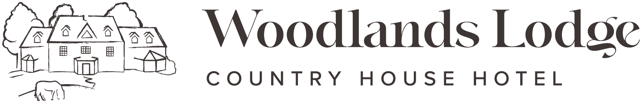
Cattlegrid Restaurant Menu

Nibbles
Olives (Vg/ GF) £3.00
Hummus and Pitta (Vg) £3.00
Nuts (GF/ Vg) £3.00
Focaccia, Oils & Balsamic Vinegar (Vg) £3.00
Light Bites
Meat Platter, Parma ham, chorizo, salami, olives, gherkins, sundried tomatoes, focaccia
£10 for one | £18 for two (GF on request)

Cheese Platter, Lyburn Gold, Tunworth, Isle of Wight Blue and fried brie, chutney, celery, grapes, crackers, £12.50 for one | £20 for two (GF on request)
Vegetarian Platter, Grilled vegetables, halloumi, olives, sundried tomatoes, nuts, gherkins, focaccia, bread rolls £10 for one | £18 for two (V/Vg & GF on request)
Bowl of Chips £4.50 (GF/Vg)
Starters
Soup of the Day, Homemade focaccia (GF on request / Vg) £6.50
Game Terrine, Red onion jam, rocket, bread crisps (GF) £7.50

Tomato Tatin, Toasted nuts, watercress (V) £7.00

Stuffed Mushroom, Rocket salad and paprika oil (Vg/GF) £6.50 | £13.50 as a main
Smoked Salmon, Cream cheese, ciabatta, fried quail egg (GF) £7.50

Smoked Haddock Fishcake, Poached egg inside and hollandaise £7.50/15.00 main

Mains
Cattlegrid Beef Burger | Buttermilk Fried Chicken Burger | Vegan Burger, Brioche bun, grilled cheddar cheese, fries & coleslaw (GF bun on request) £18.00 Beef | £15.00 Chicken | £15.00 Vegan (Vg)
Feather blade of Beef Crepe, Potato gratin, sticky red cabbage, roasted carrots, jus (GF £24.00

10oz Rump Steak, Hand cut chips, house salad, grilled tomato, blue cheese sauce (GF) £28.50 (£3.50 Supplement on DBB)
Fish & Chips, Minted peas, tartare sauce £18.00
Roast Chicken Breast, Dauphinoise, seasonal vegetables & red wine jus (GF on request) £21.00
Cod Pie, Mash potatoes & cheese on a bed of sauteed greens & grilled tomato sauce £22.00
Pollock Wrapped in Parma Ham, Crushed new potatoes, roasted garden vegetables,
and herb oil (GF) £22.00

Pumpkin & Chickpea Curry, Scented rice & poppadom (GF/Vg) £19.00
*Chicken can be added to the curry on request £2.50 supplement.
Gnocchi, Roasted squash, spinach, mushrooms, cherry tomatoes, mozzarella balls, paprika oil (V/ VG on request) £17.00

Desserts
Dark Chocolate Mousse, Chocolate crumb, vanilla whipped cream (GF) £8.00

Apple & Blackberry Crumble, Custard or Ice Cream £7.50

Biscoff Cheesecake, White chocolate and brownie ice cream, raspberry puree £7.50
Blackberry Mini Tart, Dehydrated raspberries & blackberry puree (Vg) £7.50
Lemon Tart, Spiced berry compote, shortbread £7.50

Selection of Ice-cream or Sorbets, Winter berries, chocolate flake (GF/Vg options) £8.50
Selection of 3 Cheeses, Crackers, grapes, celery, homemade chutney (GF on request) £12.00 (£2.50 supplement on DBB)
Coffee & Mini Cake, Choice of carrot cake, chocolate brownie or flapjack £7.50

