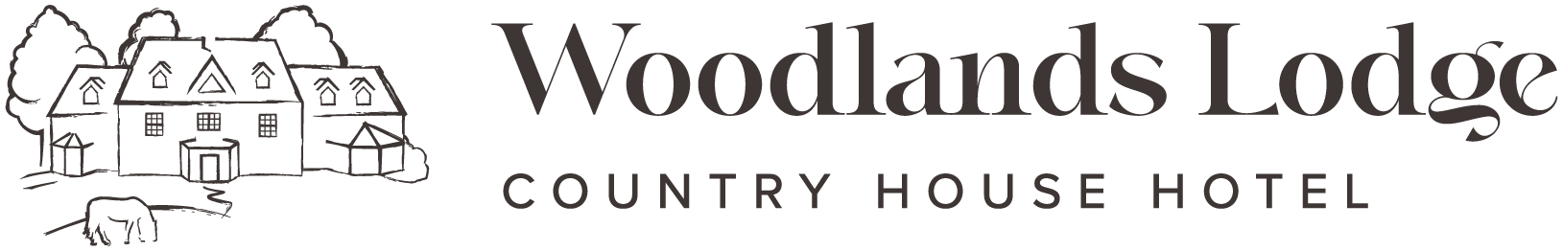
Cakes
Chocolate Brownie £4.00
Carrot Cake £4.00
Flapjack £4.00
2 Scones, Cream & Jam £7.50

Sandwiches
Chicken, Pesto, Sun Blushed Tomato & Rocket £8.50
Cheddar Cheese & Pickle £7.50(v)
Ham & Tomato £7.50
Choice of Brown / White Bread or Ciabatta Roll (Gluten Free on request

Brunch
Eggs Benedict, muffin, with 2 poached eggs, sliced ham & Hollandaise £11.50 (GF on req)
Eggs Royale, muffin, with 2 poached eggs, smoked salmon & Hollandaise £11.50 (GF on req)
Eggs Florentine, muffin, with 2 poached eggs, wilted spinach & Hollandaise £11.50 (V/ GF on req)
Waffle, bacon & maple syrup, berry compote (V& GF on req) £9.00
Smoked salmon, scrambled egg & smashed avocado on a muffin £11.50 (GF on req)

Nibbles
Olives £3 (vg/GF)
Hummus and Pitta £3 (Vg)
Nuts £3 (vg/ GF)
Focaccia, oils & vinegar £3 (Vg)
Vg= Vegan | V = Vegetarian | GF= Gluten Free – certain dishes can be made GF on request they may need adapting so please let us know your allergen on ordering your meal
If you have any food allergies or intolerance’s, please speak to our staff about our requirements before ordering your meal. Our kitchen ovens use gluten, nuts, shellfish, and we cannot guarantee that our meals do not contain traces of these allergens.

Lunch
Soup the Day, with focaccia £6.50 (GF/ Vg)
Fish & Chips, with chunky chips, minted peas, tartar sauce £17.00
Cattlegrid Beef Burger | Buttermilk fried Chicken Burger | Vegan burger, brioche bun, grilled cheddar cheese, fries, house salad & coleslaw (GF bun on request) £18.00 Beef | £15.00 Chicken | £15.00 Vegan (Vg)
Gnocchi, roasted squash, spinach, cherry tomatoes, mozzarella balls, paprika oil (V/ VG on request) £17.00

Light bites
Meat Platter, Parma ham, chorizo, salami, olives, gherkins, sundried tomatoes, focaccia £10 for one | £18 for two (GF on req)
Cheese Platter, Lyburn, Isle of White Blue, Tunworth, fried brie, nuts, chutney, celery, grapes, crackers, bread rolls £12.50 for one | £20 for two (GF on req)
Vegetarian Platter, grilled vegetables, halloumi, olives, sundried tomatoes, nuts, gherkins, focaccia, bread rolls £10 for one | £18 for two (GF on req)
Bowl of Chips £4.50 (Vg)

Desserts
Trio of Ice cream or Sorbet (GF/ Vg) £8.00
White Chocolate Panna cotta, winter berry puree (GF) £7.50
Blackberry Mini Tart, dehydrated strawberries & blackberry puree (Vg) £7.50

Vg= Vegan | GF= Gluten Free – certain dishes can be made GF on request they may need adapting so please let us know your allergen on ordering your meal
If you have any food allergies or intolerance’s, please speak to our staff about our requirements before ordering your meal. Our kitchen ovens use gluten, nuts, shellfish, and we cannot guarantee that our meals do not contain traces of these allergens.

